EX:NO:12 FOREIGN TRADING SYSTEM

USE CASE DIAGRAM:
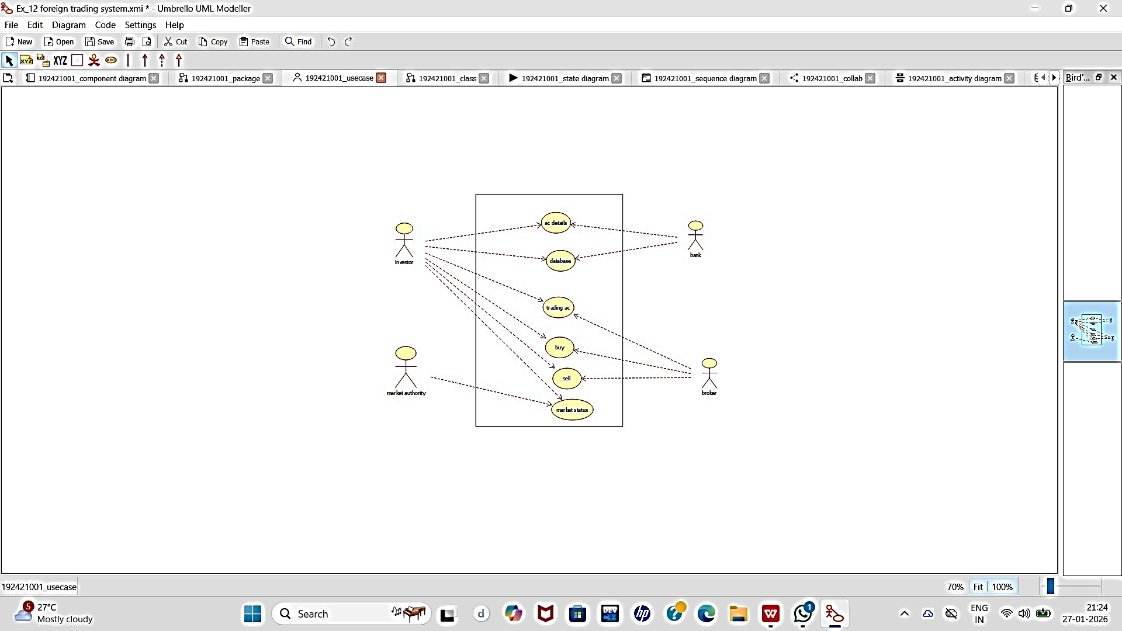

CLASS DIAGRAM:

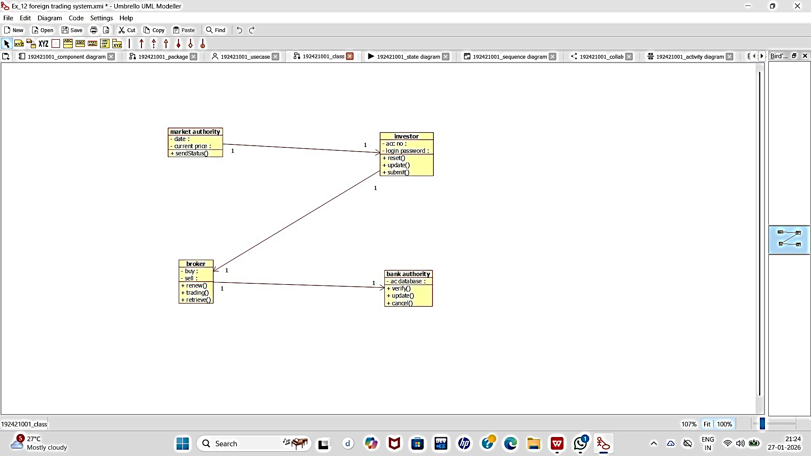

ACTIVITY DIAGRAM:

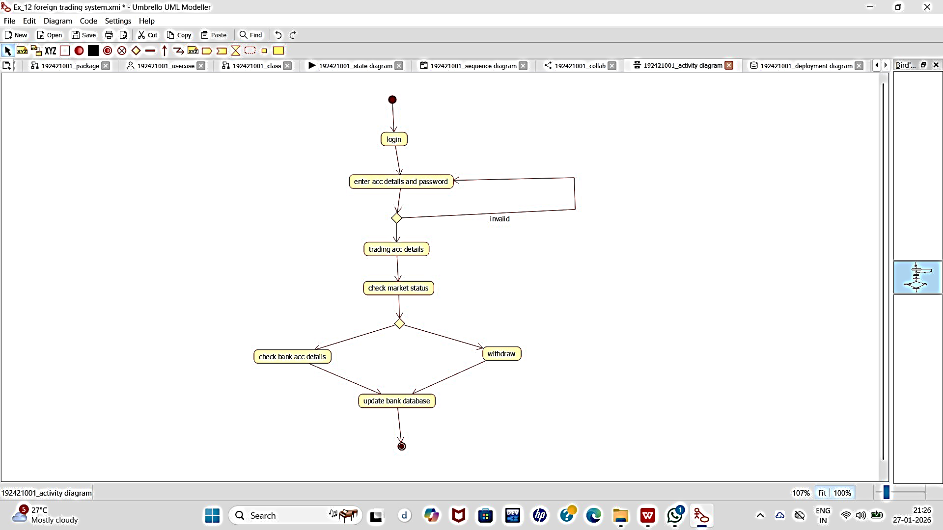

SEQUENCE DIAGRAM:
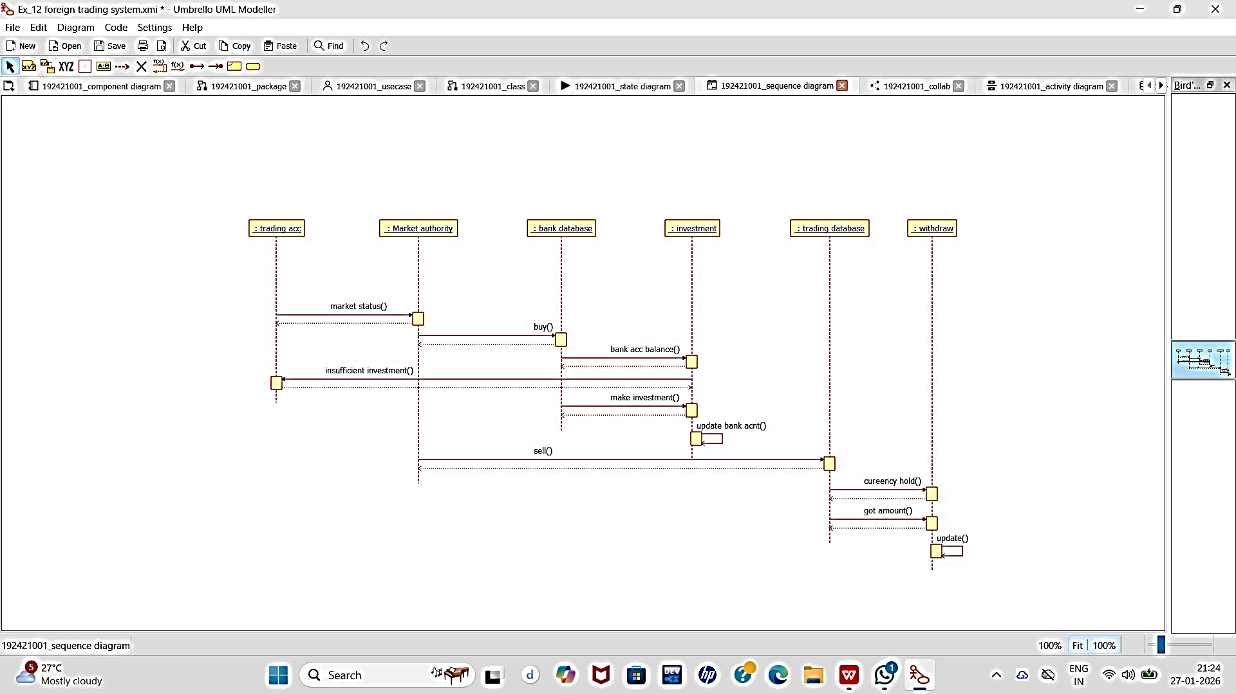

COLLABORATION DIAGRAM:

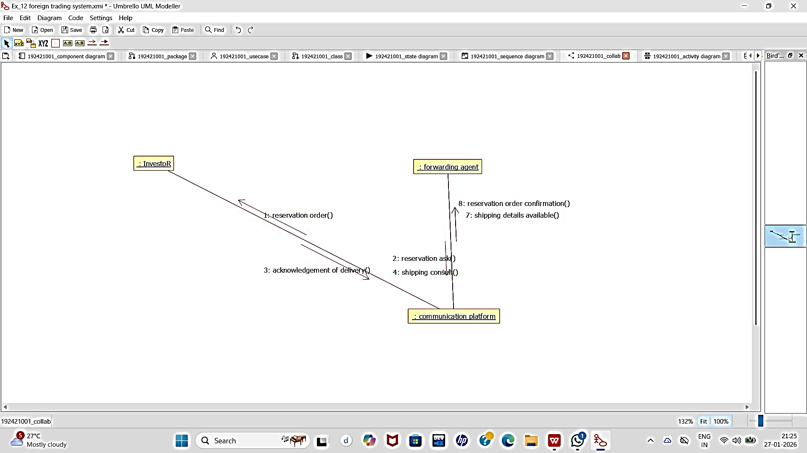

STATECHART DIAGRAM:
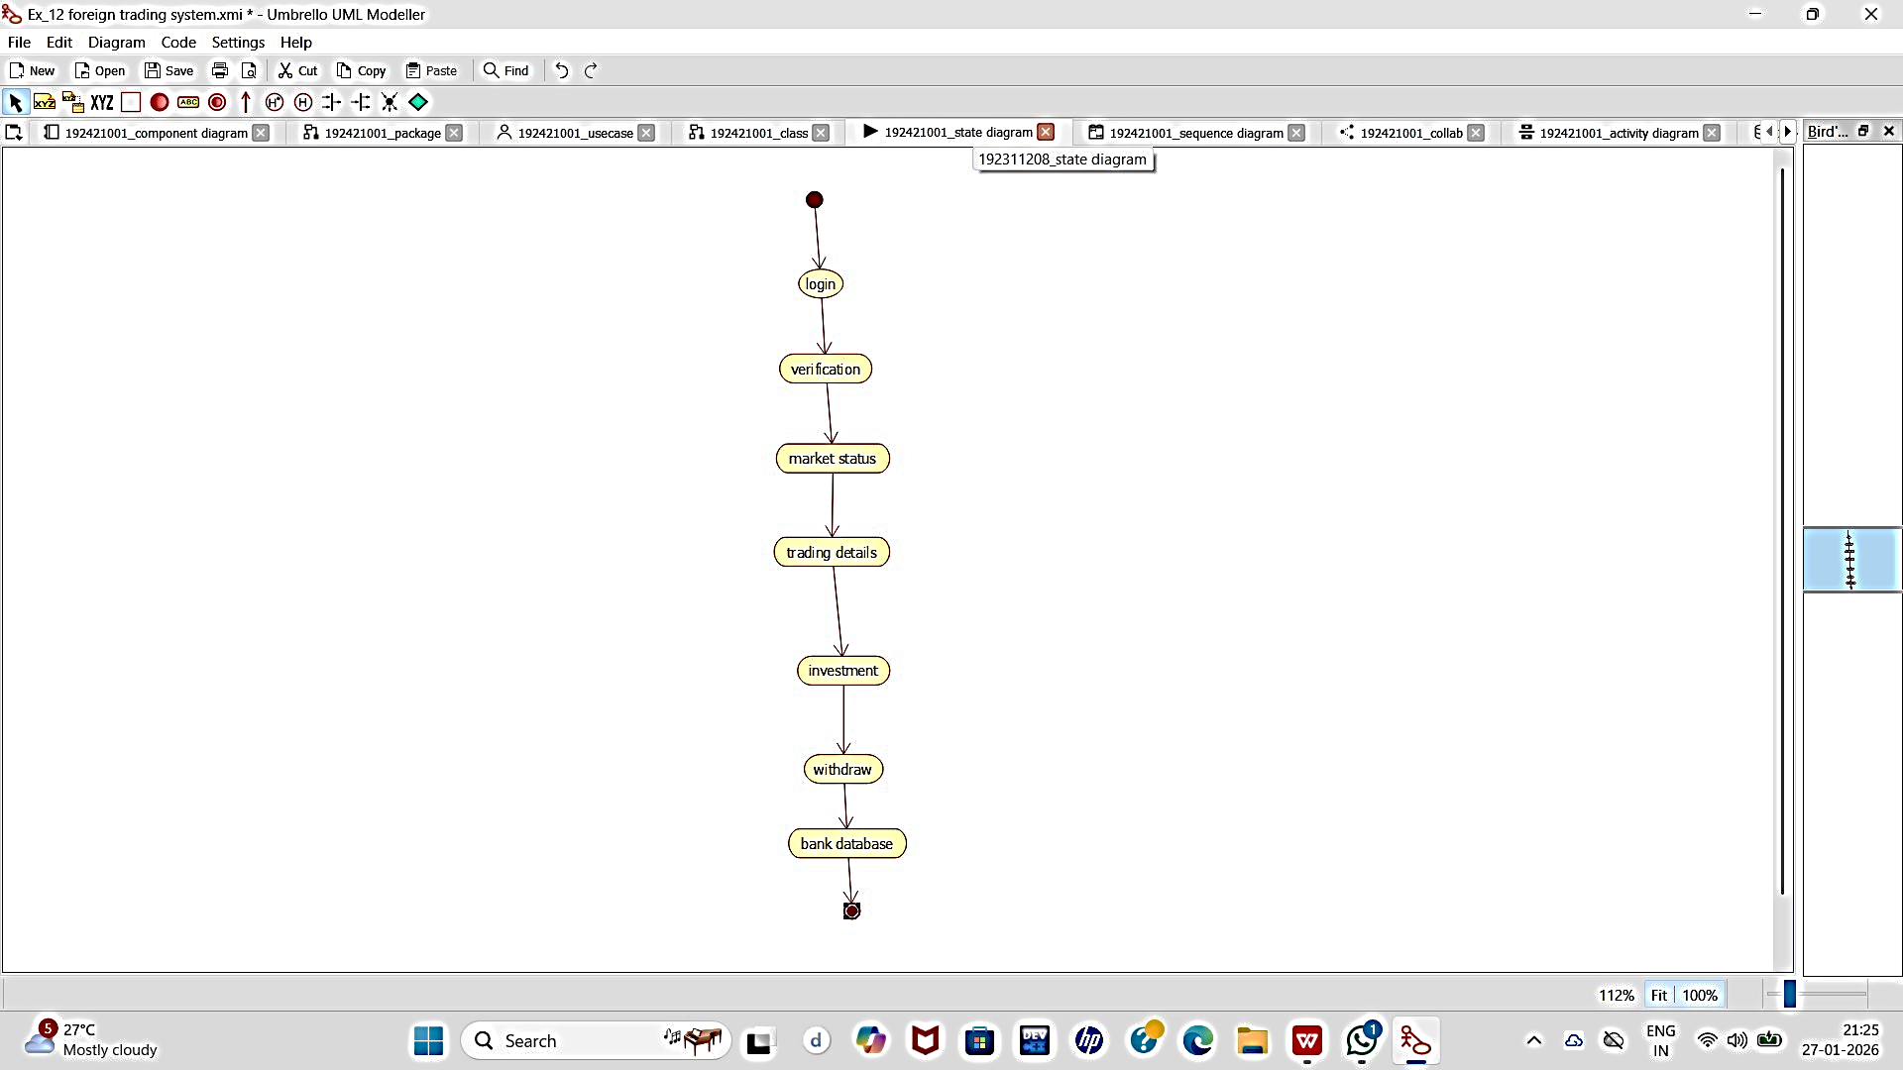

COMPONENT DIAGRAM:

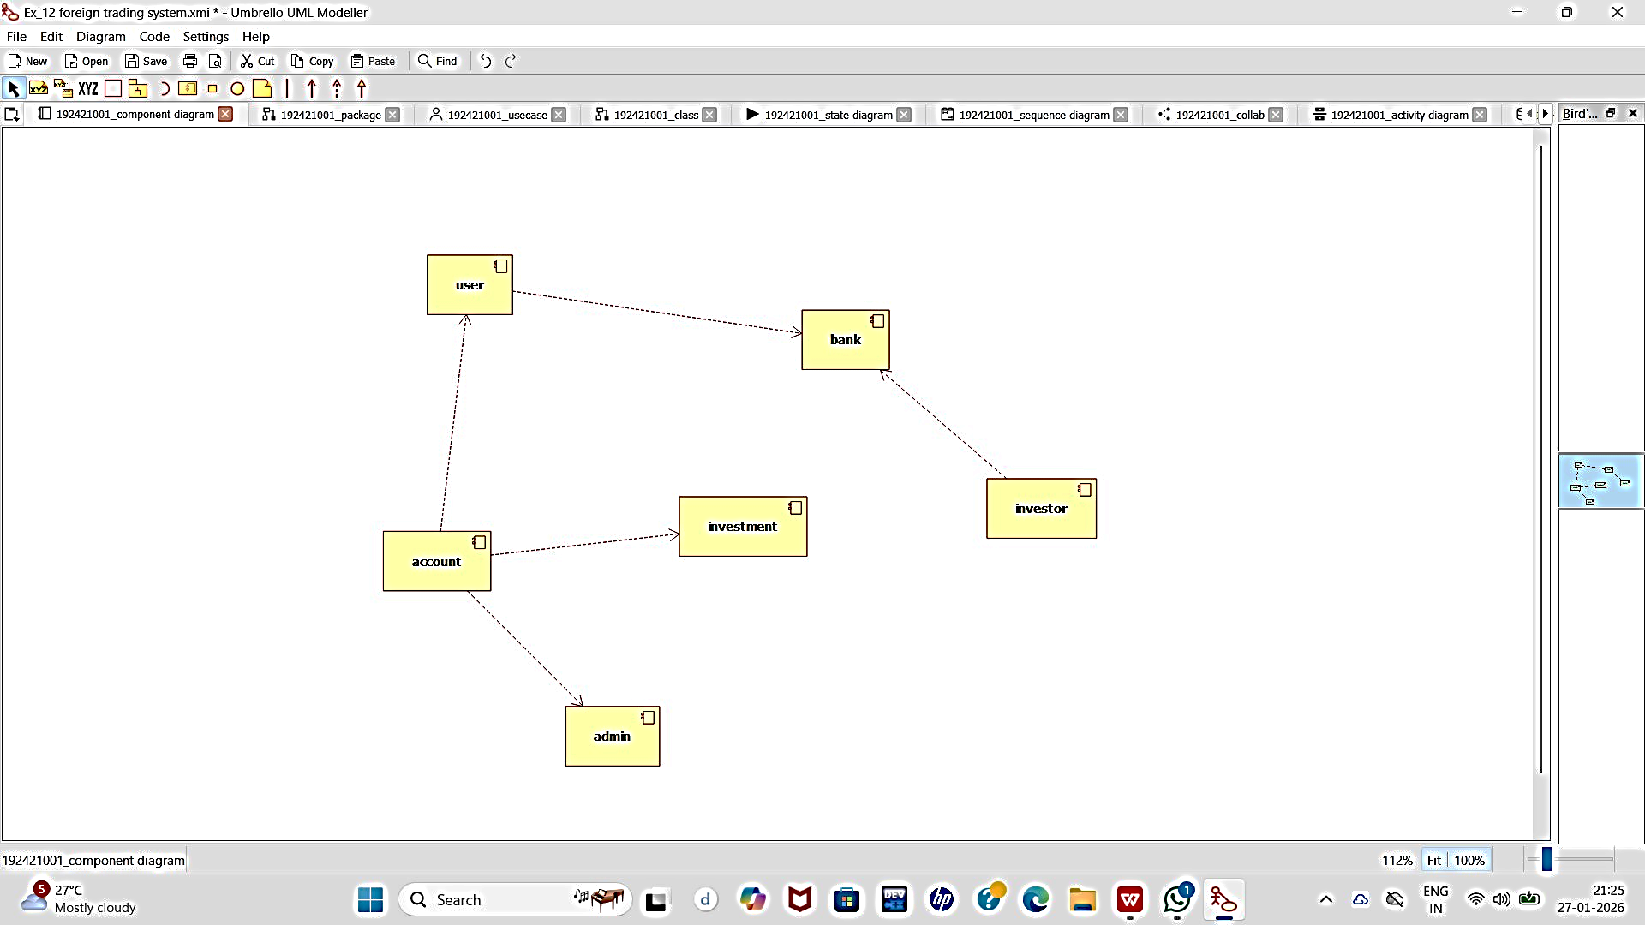

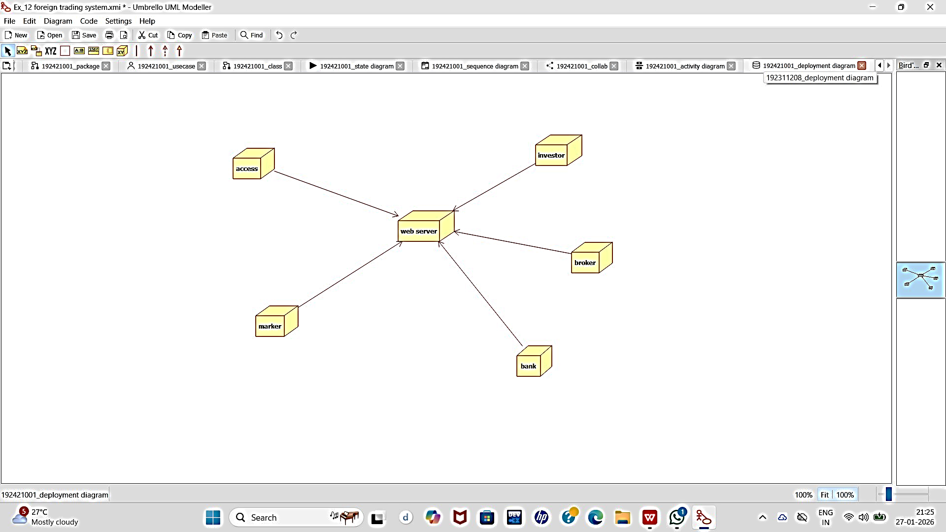
DEPLOYMENT DIAGRAM:

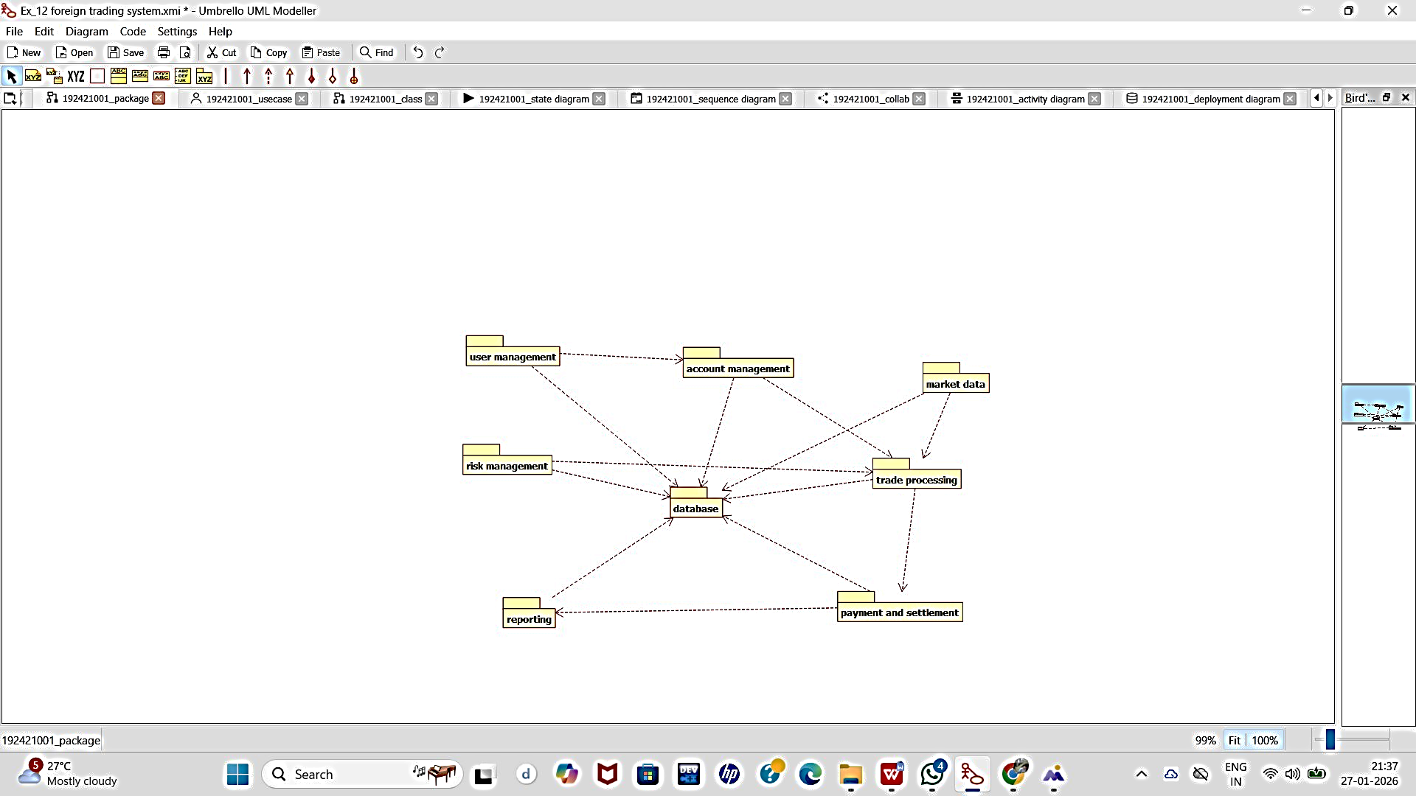
PACKAGE DIAGRAM:

